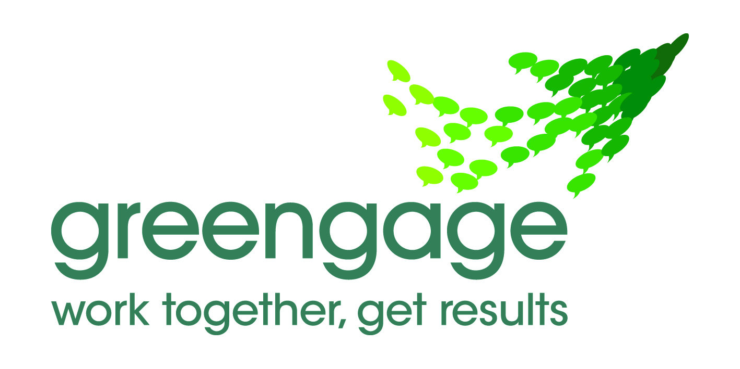 | Lancashire Shadow Health and Wellbeing Board  Intervention planning

Purpose

This report sets out a template for use in preparation of the work programme for each of the Health and Wellbeing Board’s ten interventions. The template is designed to;

- Create clarity on the desired impact of each intervention and on the specific roles of partners in delivering the intervention.
- Make explicit the shifts in ways of working that will allow partners to deliver the intervention.

The planning template

- Reality
What’s the current reality?
- Alcohol misuse has a huge impact on the health of the population in Lancashire adversely affecting disadvantaged communities leading to loss of life as well as increasing costs to the NHS. In 2011/12, it is estimated that PCTs in Lancashire spent £71.9 million on PbR tariff alone treating alcohol related conditions, with £15 million in treating conditions wholly attributable to alcohol.
- The increasing costs of alcohol related admissions are not sustainable and the hospital liason services to care for people with alcohol misuse needs to be transformed.
- Addressing alcohol misuse is a priority for many CCGs. It has also been identified as a priority intervention within the draft health and wellbeing strategy for Lancashire.
- The Lancashire improving outcomes board has also identified addressing alcohol related admissions as a service transformation area.
- There is inequity and variation in the service provision, especially the hospital alcohol liaison service and targeted identification and brief advice - two of the seven high impact changes identified by the Department of Health’s Alcohol Learning Centre.

- What is currently working well?
- Existing commissioned hospital alcohol liaison HAL schemes exist in Lancashire. Local schemes are bespoke depending on need and circumstance and not ’one size fits all’.
- NHS Central Lancashire have worked through the contracting process with Lancashire Teaching Hospitals NHS Foundation Trust to deliver hospital based IBA for adult admissions
- Public Health Network Alcohol Programme Manager assists coordination and collaboration through the Lancashire Alcohol Network (LAN). LAN input influences effective collaborative working across partnerships at district and County levels.
- Strong evidence base for hospital alcohol liaison (HAL) and Identification and brief advice (IBA) interventions as two of the seven High Impact Changes to reduce alcohol harm. Evidence of alcohol liaison outcomes based on ‘invest to save’ and cost avoidance principles is strong. NWCEO’s .Locality business cases predicated on this.
- Partners involved in alcohol harm reduction partnerships have identified alcohol impacts as a priority.
- Succesful Pan Lancashire business case for transformation funds submitted through the LIO board for hospital alcohol liaison services in the hospital and urgent care settings. Please see attached appendices 'A', 'B', and 'C'.

NHS Evidence (2011): Alcohol Care Teams: to reduce acute hospital admissions and improve quality of care
NICE (2010): Alcohol-use disorders: preventing the development of hazardous and harmful drinking
NICE (2010): Alcohol-use disorders: Diagnosis and clinical management of alcohol-related physical complications
NICE (2012): Alcohol Pathways http://pathways.nice.org.uk/pathways/alcohol-use-disorders
- What is getting in the way of partners achieving desired impacts?
- Sustainable funding for alcohol liaison nurse resources. N Lancs has some specific funding, East has improvised a resource and Central has an in-reach service as part of its drug and alcohol services. Business case identified above will ‘kick start’.
- Generally, hospitals and urgent care centres lack screening processes to identify alcohol related conditions on presentation and staff lack awareness and training to recognise issues and deliver information and brief advice (IBA).
- Significant progress has already been made in discussing liaison services with partners. However, the need for this service requires constant re-enforcement with colleagues across acute trusts to ensure that a partnership approach to service implementation can be achieved.
- Lack of effective clinical pathways between hospital, primary care and community services to reduce repeat attendance and admission by ‘frequent attenders’.
- Where are the gaps in service delivery that really matter?
- Equity of access to alcohol liaison across Lancashire ie in-reach service only in central Lancashire, NL only at BVH, East at RBH. The lack of equitable service delivery across Lancashire impacts on re-admissions and the long term prognosis for patients with chronic conditions caused or exacerbated by alcohol.
- Alcohol related condition screening and identification in hospitals and primary care Urgent Care Centres is inconsistent across Lancashire. Many areas have low levels of professional awareness of alcohol screening tools and IBA techniques. However, some developments are being taken forwards in central Lancashire through use of CQUINs.
- Lack of effective and consistent referral and clinical pathways between hospital, GP and community services.
- What are the issues and opportunities that must be addressed if we are to make a breakthrough? i.e. what really matters?
- Commission hospital alcohol liaison services for Lancashire residents.
- Leadership from senior management in strategic health planning and acute hospital trusts to influence and lead the buy-in to alcohol liaison as a means to health improvement and reducing associated costs to health services and other partners.
- Opportunity to publicise JSNA findings and evidence base for intervention impacts.
- Provision of alcohol awareness, IBA training for appropriate staff and incorporate IBA delivery into primary and secondary care contracts.
- Identify and agree 'best fit' liaison model and target groups ie dependent drinkers (frequent flyers) or dependent + increasing risk or universal whole patient group approach.
- Identify robust data systems and cost benefit tools to demonstrate effectiveness and outcomes.
2. Results
What does success look like?

2.1 Longer-term impact

- What will be the 3 to 5 year impact of the intervention?
- Please see attached business case for outcome details
- Reduction in the rate of increase of alcohol related hospital admissions and A&E repeat attendances.
- A reduction in the number of alcohol specific re-admissions and A&E representations within 30 days.
- A reduction in bed days associated with managing acute alcohol withdrawal (AAW)
- Demonstrable cost savings
- Improvement in Lancashire Alcohol Profiles for England (LAPE) across Lancashire 12 districts.
- Improved quality of care for people admitted to hospital for alcohol specific and alcohol related conditions.
- Reduced health service utilisation (pre and post intervention) by patients supported by the alcohol liaison service.
- Improved treatment pathways between hospital, primary care and access into community treatment services
- Skill development within the acute sector workforce through training in identification and brief advice and management of AAW.
- A reduction in alcohol fuelled violence and aggression against hospital staff.
- What are the longer-term measures of success?
- Contribute to a reduction in the rate of increase of alcohol related hospital admissions
- Contribute to reducing demands on partner services from alcohol related issues.
- With the association alcohol has to other conditions including mental health, cancer and CVD this work should make a contribution to positive impacts on these outcomes over the longer term

2.2 Impact in the year ahead

What specific goals will the intervention achieve in the next year?
- Please see attached business case for outcome details
- Reduce alcohol related hospital admissions by ensuring an equitable level of service is in place across Lancashire.
- To expand capacity of alcohol liaison nursing in acute settings that incorporates assertive outreach and integration with community in reach services.
- To develop skills within primary and secondary care workforce through training in Identification and brief advice
- Produce referral and clinical pathways between hospital, GP and community services appropriate to each locality.
- To support peer to peer learning between organisations
- Establish robust data collection and monitoring systems to evaluate the impact of the changes on alcohol related admissions

- What are the specific measures of success for the year ahead?
- How will the Health and Wellbeing Board know that the intervention has achieved its goals?
- Please see attached business case for outcome details
- Sustainable resources are identified to facilitate alcohol liaison service provision.
- Alcohol liaison established equitably in all A&E and acute hospital settings in Lancashire by September 2013, embedded as part of local alcohol service provision.
- Alcohol liaison established in hospital acute settings and Urgent Care Centres as appropriate.
- Effective clinical pathways are established between hospital, primary care and appropriate community services.
- Lead officers will produce quarterly progress reports on key deliverables for H&WB responsible members for programme monitoring and feedback to the Board.

- Response
What needs to happen to ensure partners achieve better results?

  - Shifts in the way that partners deliver services

- How must partners work to ensure that the ‘priority shifts’ are applied and the intervention is effectively implemented?
- Partners must promote awareness of the impacts that alcohol has on services and the benefits of alcohol liaison as a harm reduction intervention to prevent ill health and reduce demand for services.
- Partners must commit to engagement in the work programme and contribute to the implementation of alcohol liaison as a priority objective. ensuring that our alcohol services are working effectively and efficiently to ensure we maximise the impact from alcohol liaison.
- Partners must communicate openly regarding barriers to achieving objectives.
- Partners must commit to pathways and joint working to delivering accessible services within hospital and community settings to improve the experience of moving between primary, hospital and social care.
- Partners must commit to training and raising awareness for frontline staff to facilitate identification of alcohol harms, adopting screening tools for identification, delivering information and brief advice and pathways for signposting.
- Influence of HWB/CCG’s to promote planning priorities

  - Programme of work

- Who needs to be involved to develop, commission and deliver the intervention?
Engagement and participation of the following partners will be essential for effective implementation of this project. All stakeholders will need to reflect arrangements pan-Lancashire;
- Clinical Commissioning Groups (as future lead commissioners for acute services & for clinical input)
- Community Alcohol Service Providers (ensuring developments are embedded within/aligned to care pathways)
- Drug and Alcohol Action Teams (as current lead commissioners for community alcohol services)
- Finance leads (for modelling financial impact of project delivery)
- Primary care (as the setting for IBA intervention)
- Hospital Trusts (as the setting for HALS intervention)
- Lancashire County Council Adult Social Care (for reducing admissions by frequent attendees and for length of stay for general alcohol related admissions)
- Local alcohol leads (as project managers at local level – often also fulfilling the public health role)
- Patient involvement (appropriate to needs and circumstances of the diverse range of service users)
- Public Health (for evidence base including critical appraisal of scientific evidence and health needs)
- Upper tier and unitary authorities (as future commissioners of drug and alcohol services)
- What are the ‘milestones’ for the Task Group in the year ahead?
- Implement schemes locally using available resources and consider recommendations for shifting existing health resources to prevention and early interventions.
- Engage all key stakeholders in planning alcohol liaison services as per 3.2 above.
- Develop locality implementation plans including; agreement of liaison model and target groups, specification and performance management indicators, and provider mobilisation plans including staff recruitment and agreed commencement date.
- What are the specific activities to be carried out by each partner?
- Awareness raising and engagement of partners to develop local implementation plans. (Commissioners/partners)
- Negotiate potential for resource shift with partners and providers ie acute trusts'
- Negotiate contracts with acute trusts including finance, service model, performance management framework etc. and ensure service equity across Lancashire (commissioners NL/CL/EL in collaboration with unitaries as required and provider stakeholders)
- Provider mobilisation including recruitment of staff , protocols and pathways, staff training. ( providers)
- Develop referral and treatment pathways between hospitals, primary care and community treatment services and signposting to other partners. (all)
- Achieve full implementation of service and evaluation (all)
Appendix 1
Priority shifts in the ways that partners deliver services

- Shift resources towards interventions that prevent ill health and reduce demand for acute and residential service

- Build the assets, skills and resources of our citizens and communities

- Promote and support greater individual self-care and responsibility for health; making better use of information technology and advice.

- Commit to delivering accessible services within communities; improving the experience of moving between primary, hospital and social care.

- Make joint working the default option; pooling budgets and resources to focus on priority outcomes, commissioning together on the basis of intelligence and evidence; sharing responsibilities for service delivery and combining services in the most effective way; sharing risk.

- Work to narrow the gap in health and wellbeing and its determinants

